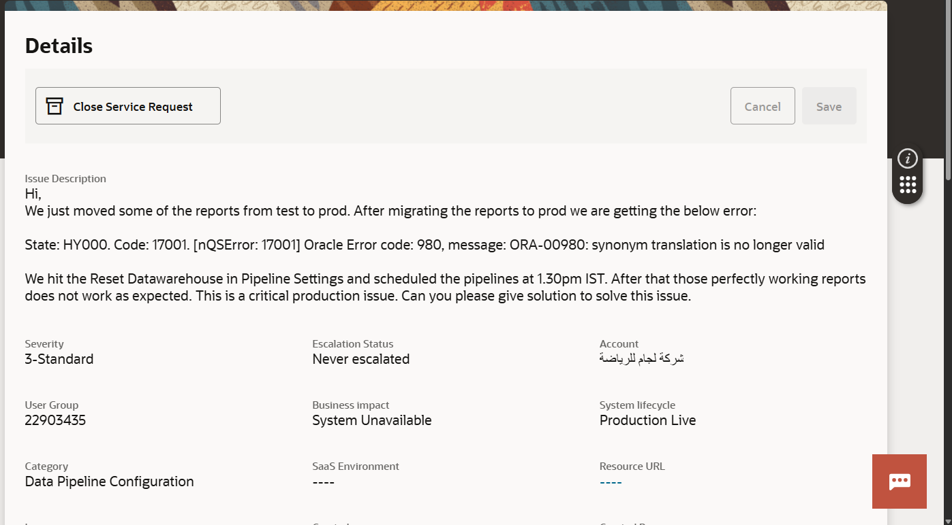

We performed Reset Data warehouse and Scheduled the Pipeline in Pipeline Settings, ended up getting this error. Contacted Oracle Support they explained that in Oracle Cloud, if you are performing any operations along with scheduling process.

Start the activity before 3hrs of scheduling or Schedule the task after 3hrs of completing the activity. Because Oracle Cloud has 3hrs buffer time. If anything like reset data warehouse or some other thing is needed to be done that should be done before 3hrs or after 3hrs.

For example if we perform reset data warehouse at 12.45pm and schedule the pipeline at 1.30 pm, the pipeline won’t run. Because the 3hrs buffer is not applied here.

And,

Reset Data warehouse operation should be performed only when there is need to remove the tables and to make the functional areas inactive. Otherwise Reset data warehouse should not be performed because it drops all the tables and makes the functional areas go inactive. The pipeline won’t run.

In order to make the pipelines to run on the scheduled time, the functional area need to be activated again. Once the functional areas are activated the pipelines will execute the full load and it be assigned to the schedule automatically.

If we are not activating the functional areas, the pipeline won’t run, and even if we perform reset and reload operation, it will be moved to skipped status and the pipeline won’t run.

So, if Reset Data warehouse operation is performed, we need to reactivate the functional areas once again.

For example, if there are 60 functional areas, we have to eliminate 30 areas and keep only the specific 30 then we a can use Reset data warehouse, so that 30 areas will be deactivated, and the tables will be dropped.

Then we have to reactivate the remaining 30 areas. If the areas are inactive (that is in “Saved” Status), the pipelines won’t run.

Avoid using Reset data warehouse to update the data in the tables, instead use Reset and Reload option to update the data in the table.

Use data warehouse only when tables need to be dropped or when functional areas need to be deactivated.

The best option to use is the Reset and Reload option and remember the 3hrs buffer time.

The Request History in data configuration can be used to monitor the status of the full load task status.

Oracle Docs:

[Reset the Data Warehouse](https://docs.oracle.com/en/cloud/saas/analytics/25r1/fawag/reset-data-warehouse.html)

[Reset and Reload the Data Source](https://docs.oracle.com/en/cloud/saas/analytics/25r1/fawag/reset-and-reload-data-source.html)

[Generally Available Features](https://docs.oracle.com/en/cloud/saas/analytics/24r3/fawag/generally-available-features.html)